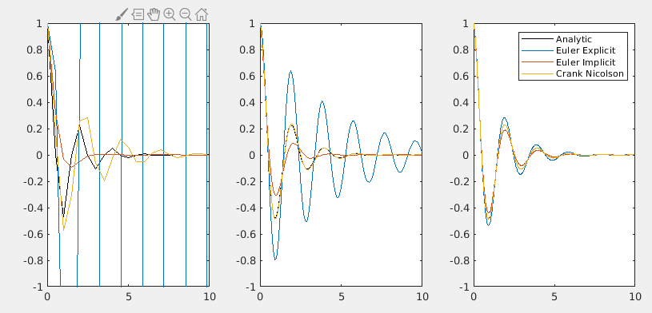
Figure 1) Left to right, N = 20, 100, 500.
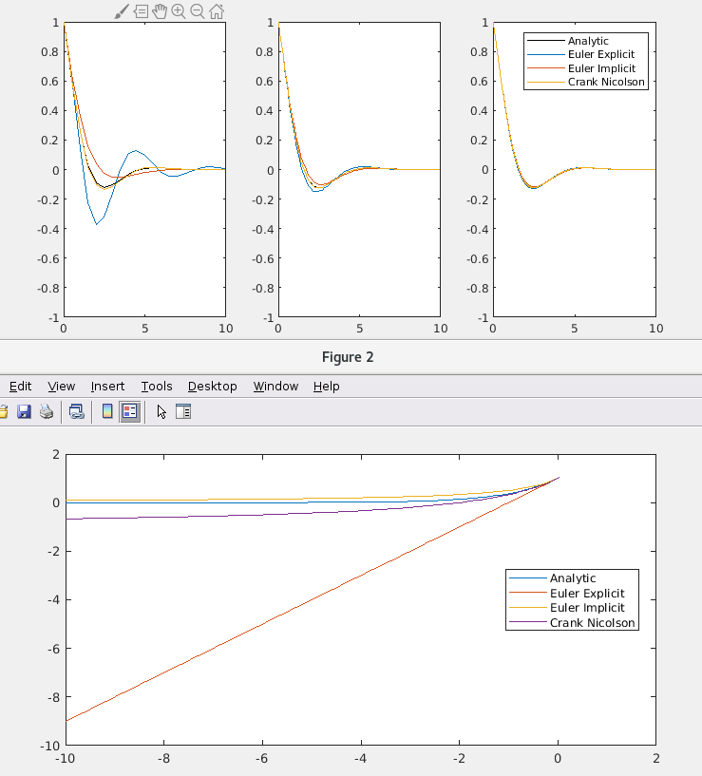

Figure 2) G(z) The Crank Nicolson scheme is a 2nd order scheme and should provide a better approximation of the exact solution.
The imaginary parts lead to phase shifts/oscillatory behavior as opposed to amplification and are hence not as important to the current stability analysis.

4)
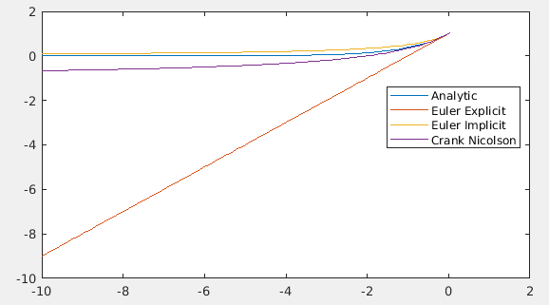

5) Stability:
For question 2 and task 3 we have the following z values and magnitudes:

Question 2:
-0.3750 + 1.5708i
-0.0750 + 0.3142i
-0.0150 + 0.0628i
Question 4:
-0.3750 + 0.5000i
-0.0750 + 0.1000i
-0.0150 + 0.0200i

Euler explicit:
We know that stability is ensured if |1 + z| <= 1
Hence it is only N = 20 for question 2 which is unstable. This can be seen in the following stability diagram:
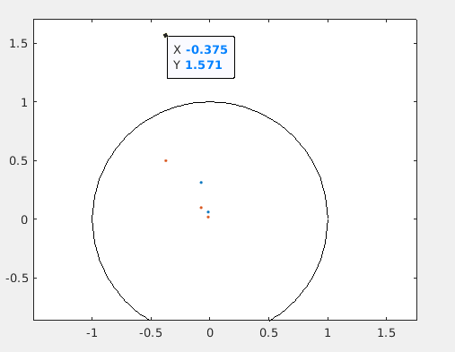

Euler Implicit:
We know that the Euler implicit method is unconditionally stable (shown in lectures), hence we have stability for all.

Crank-Nicoloson:
instead of drawing the diagram I have just computed the G(z) for all cases:
Question 2 Question 4
0.7937 0.7005
0.9294 0.9279
0.9851 0.9851
They are all below 1.

Accuracy:
For accuracy both Euler methods are equally accurate (first order) and Crank-Nicolson is 2nd order.

Task 3
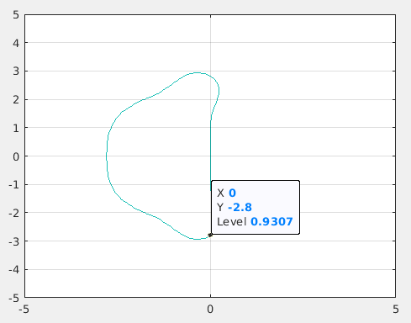

Figure 3) Complex plane showing region of stability (note it should be shaded inside to show stability)

